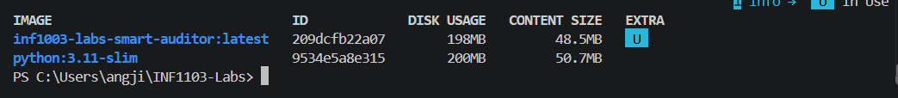
https://github.com/angjiaxin/INF1103-labs.git

